“PHARMWATCH”
MINISTRY OF HEALTH
DRUG MONITORING FORM

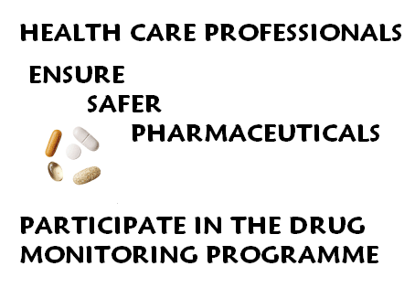Report drug failure and adverse reactions with
medications and suspected counterfeit product

An adverse reaction occurs when the patient outcome is:
Death, life-threatening (real risk of dying), hospitalization (initial or
prolonged), disability (significant, persistent or permanent),
congenital defect, permanent impairment, allergic reactions,
gastrointestinal distress.

Report even if:
- You’re not certain whether the product caused the adverse reaction
- You don’t have all the details

Who can report?
Any health care professional (Physician, Pharmacist, Dentist, Nurse)
Any patient who has experienced an adverse drug reaction

Where to report:
After completing, please return this form to: Dr. Maxine Gossell-Williams
Department of Basic Medical Sciences
Pharmacology Section, University of the West Indies
Tel: 927-2216; fax 977-3823
Email: maxine.gossell@uwimona.edu.jm

or or
Mrs. Valerie Germain Ms. Angelika Steiner
Standards & Regulation Division Standards & Regulation Division
Ministry of Health Ministry of Health
45-47 Barbados Ave, Kingston 5 45-47 Barbados Ave, Kingston 5
Tel: 633-7150: fax: 630-3630 Tel: 633-7148 fax: 630-3630
Email: germainv@moh.gov.jm Email: steinera@moh.gov.jm

For additional information or for reporting online please visit the Ministry of Health’s website at www.moh.gov.jm

What happens when the Form is submitted?

Any information provided in this form will be handled confidentially. The identities of the health care professional, patient or any other person reporting will be held in strict confidence and protected to the fullest extent. All reports will be assessed and causality analysis decided by Ministry of Health in due course. It is the ultimate responsibility of MOH to decide how to act on the information. It is also the responsibility of the Ministry to decide whether the incidences of reports will require further evaluation of drug performance. The Ministry will further provide the relevant pharmaceutical company with a summary of its findings and subsequent decision regarding intervention.

Prepared by: Maxine Gossell-Williams
Department of Basic Medical
Sciences Pharmacology Section

Princess Thomas Osbourne
Standards & Regulation Division Ministry of Health

2009 May

“PharmWatch” is a collaborative effort between the Ministry of Health and
the Pharmacology Section of the University of the West Indies.

“PHARMWATCH” DRUG MONITORING FORM

A. PATIENT DETAILS
1.Patient Initials: (First, Last) | 3.Gender:  M F | 3. Date of Birth:  ^{(mm/dd/yyyy)} |  | 4. Ethnicity |  |  | 5. Weight:((Kg) |  | 6. Height: (cm)

B. SUSPECTED DRUG EVENT
7. Outcomes attributed to use of drug  (check all that apply):  Failure of therapy Allergy  Disability Life threatening Hospitalisation  Death______________  mm/dd/yyyy  Other (describe)___________________ |  |  | 8. Describe event or problem |  |  |  |  |  |  | 9.Date event started (mm/dd/yyyy)
10. Date event ended
(mm/dd/yyyy)
11. Describe action taken in response (e.g. drug changed, prolonged-therapy, increased dose) |  |  | 12. Describe other relevant history including abnormal laboratory test results, days of hospitalization.
C. DRUG INFORMATION
13.Name of suspected drug  (give specific name on package) |  |  | 14. Dose & Route |  |  | 15. Indication |  | 16. Batch number if known
17. Name of other drugs taken  (give specific name on package) |  |  | 18. Dose & Route |  |  | 19. Indication |  | 20. Batch number if known

D. REPORTING HEALTH PROFESSIONAL INFORMATION
21. Profession:__________________________________  22. Name: _________________________________________  23. Address: _________________________________________________ |  |  |  |  |  | 24.Telephone: _____________  25. Fax: ___________________  26. Email______________________________________
27. Also reported to:

Signature Date (mm/dd/yyyy)

FOR OFFICIAL USE ONLY
Code No

Received by:  Date received: |  |  |  |  | Action taken:

